**Experiment No :** 19

**Experiment name :** To print all prime number numbers in a given range using a function .

**Methodology :**

1. Prime Number is a program through which we can find those numbers that are divisible by two or that number is divisible by any other number that has a divisor. The method we use to do this is n !=2.

**Flow-Chart :**

Read n

int n1 , n2 , i , flag ;

i=2

F

i ==n

i=i+1

N%i==0

i<n

for(i=n1+1 ; i<n2 ; ++i

n1 = n1+n2 ;

n2 = n1-n2 ;

n1 = n1 -n2 ;

if(n1>n2)

Input number

scanf("%d %d", &n1 , &n2);

T

T

F

flag = checkPrime(i);

if(flag == 1){

printf("%d ",i);

**Code :**

Print : not Prime

Print : Prime

#include<stdio.h>

int checkPrime(int n);

int checkPrime(int n){

int j , flag =1 ;

for(j=2 ; j<n/2 ; ++j ){

if(n%j == 0 ){

flag = 0 ;

break ;

}

}

return flag ;

}

int main(){

int n1 , n2 , i , flag ;

printf("Enter two number : ");

scanf("%d %d", &n1 , &n2);

//swap number .

if(n1>n2){

n1 = n1+n2 ;

n2 = n1-n2 ;

n1 = n1 -n2 ;

}

for(i=n1+1 ; i<n2 ; ++i){

flag = checkPrime(i);

if(flag == 1){

printf("%d ",i);

}

}

return 0 ;

}

**Output:**

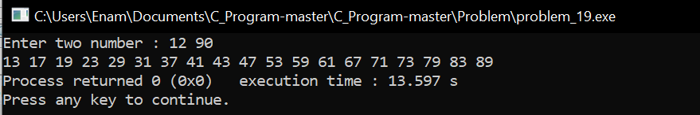

**Result discussion :**

What we have found out through this program is that we will take two numbers from the user that we will find out a range of how many prime numbers are inside the two numbers, for example, we will find out how many prime numbers are there from 1 to 60 through this programming.